FORM OF PRIOR INFORMATION

Cause of the visit back trouble □ neck trouble □ arm trouble □ leg trouble □

Name ________________________________________

Profession ________________________________________

Do you suffer from any of the following?

 | Yes | No
Cardiovascular disease
High blood pressure
Diabetes
Neurological disease
Disease in support and movement organ
Respiratory disease
Migraine
Rheumatism
Thyroid disease
Malignant tumor
Problems with mental health / stress
Allergy
Osteoporosis
Other common disease

Have you during the last two weeks felt?
 | Yes | No |  | Yes | No
Fever |  |  | Weigh loss
Deterioration in general condition |  |  | Chest pain on effort
Pain when breathing |  |  | Dizziness
Persistent headache |  |  | Trouble with stomach
Infection disease |  |  | Incontinence/urinary retention
Loss of strength in the extremities |  |  | Pain in testicles
Radiating pain in arms/legs

Do you smoke? Yes No
Are you pregnant? Yes No
How often do you exercise/form of exercise? ____________________________________________________________________________
Do you use regular medication? ________________________________________________
Have you been in an accident? ___________________________________________________

Is it the first time you experience the current pain/current trouble? Yes No
Have X-rays/MRI been made for the current pain/trouble Yes No
Have you undergone surgery for the actual pain or some other reason? Yes No
How long has the current pain/trouble lasted? _____________________________________
What do you think caused the current pain? _______________________________________
What painkillers have you been taking? ___________________________________________
Which movements/positions cause the most pain? _____________________________________________________________________________
Which movements/positions relieve the pain? ________________________________________________________________________________How much pain have you experienced on an average, during the last 2 days? Put a mark arround the number that best describes the intensity of your pain.
no pain at all 0___1___2___3___4___5___6___7___8___9___10 worst possibel pain
Your ability to work is 10 at the best. Put a mark around the number to describe your work ability.
No work ability 0___1___2___3___4___5___6___7___8___9___10 Your work ability at it´s best
PAIN CHART
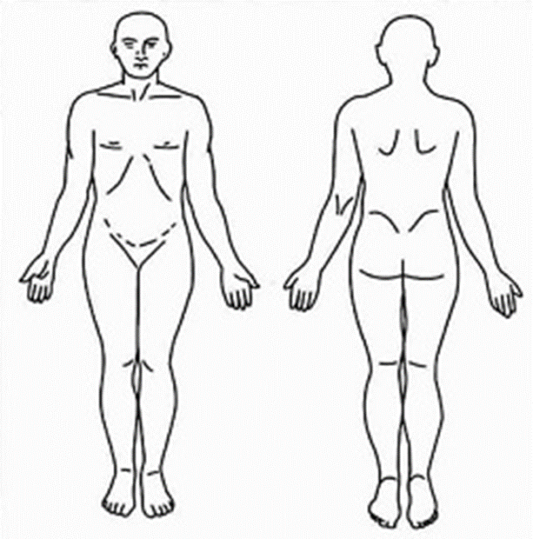
Draw in the are of the
current pain with XXX
numbness with ///
insensibility OOO
tightness in muscles +++
burning sensation ZZZ

